**Shire of Pingelly Submission to the**

**2024 Regional Telecommunications**

**Independent Review Committee**

**2024 Regional Telecommunications Review**

**Part 1 – Mobile Coverage – Testimonials**

The Shire of Pingelly is extremely concerned with the lack of reliable mobile coverage to the town of Pingelly and surrounding rural areas. Throughout the town, including town centre, it is very difficult to make or receive phone calls or even to access the internet without WI-FI. Visitors to town rely on their mobile connection to access the internet for information about the town, including maps. To go partway towards a solution for our residents, the Shire has installed free WI-FI in the centre of town. However, this service is limited.

Residents and businesses are becoming more and more frustrated with the lack of services. They are aware of the different standard of service in the metropolitan areas and feel like they are being treated like second class citizens. In most instances, mobile phone coverage is unavailable inside the shops and houses – it is necessary to go outside to make calls or to make purchases on payment devices that require mobile coverage. Many seniors within the town also rely on mobile coverage for their distress/fall alarms and/or phone applications.

Emergency services too know that it is only a matter of time until a fatal incident takes place because of the lack of mobile coverage. Emergency services volunteers rely on their phones to receive call outs. If they don’t respond because of the lack of service, or if the 000 call is unable to be placed, the consequences could be fatal.

The following are testimonials directly from people within the Pingelly community in relation to the mobile coverage within the town.

**Bendigo Bank, main street business:**

*It's both inconvenient and embarrassing having to ask our customers to stand outside for assistance with e-banking services. Sometimes even having to ask them to come back another day or try at home with WI-FI.*

**Elizabeth Trump, main street resident:**

*My phone signal totally disappears for up to 2-3 days at a time. When it comes back it only has a half bar of signal. Not Happy. I drive to Narrogin I get 5 bars of signal, same when in Perth.*

**Darryl Brown, town centre resident :**

*Yep, Telstra has definitely been worse over the last few weeks during the apparent upgrades. Living only 500m from the Pingelly Post Office too!*

**Lisa Pitman, town resident:**

*Despite numerous attempts to troubleshoot and resolve connectivity problems, reception in and around Pingelly is poor & unreliable.*

*After 5 years living here, it is now a natural reflex to grab my phone and head to a window/outside when my phone rings.*

**Josh Wholagan, rural resident:**

*Absolute joke, get no signal on most of my country, makes it bloody hard trying to run a farming business.*

**Carmel Halls, rural resident (near a telecommunications tower):**

*We’re on York Williams Rd, West Pingelly, and the mobile coverage has reduced by at least a third over the last 2 years. Spots where I could reliably make a call or search on the net have reduced. I’m not sure what will happen when the 3G network shuts down, because it’s only what I can get at times.*

**Ellen Cook, town resident:**

*I’ve made several complaints to Telstra over the last year regarding the service both in and out of town. I do a lot of remote work (often working on my laptop while my kids are at lessons), and have always been told it’s a me problem not a Telstra problem, just to reboot all of my devices and it will be fine. It never is. Our house in the town centre has several dead spots for coverage. And this is all before the upgrades. I don’t see any difference before and after the so-called upgrades. Thankfully I have a decent WI-FI provider (who isn’t Telstra)!*

**Caitlyn Wain, main street business owner:**

*We are trying to run a business, which relies on internet and phone orders. We often drop out mid-way through taking a phone order, and often have no service at all.*

**Hendrika Smith, town resident:**

*Mobile reception is such at our place (1 bar).  When we get a mobile call, we have to run out the back verandah, to get better reception. In the mean time, you hope the call does not fall out while trying to get better reception. This reception is even after the notifications that Telstra was upgrading our system earlier this month.*

**John and Val Timms, main street resident:**

*We have had a huge amount of calls dropping out, and the list goes on. Improvements definitely need to be made with the Telstra service.*

**Clinton Cheney, town resident, volunteer ambulance driver, and remote worker:**

*Since relocating to Pingelly in October 2021, despite being less than 400m from the town centre, my household has and continues to experience abysmal phone reception.*

*We have endured the inconvenience of having no phone reception indoors and at best, a measly 1 bar signal when outside. To mitigate this issue, we have invested in four RFI Telstra signal repeaters, strategically placing them in our home, office, and vehicles. This solution, however, only allows for minimal communication within the confines of our property and ties us to a small range of signal when on the property.*

*Furthermore, I own a property 5 kilometres from Pingelly, where until recently, we had a marginal 1 to 2 bars of reception with download speeds of 2.4 to 3mbps. Shockingly, the situation has deteriorated over the past three weeks to the point where there is no reception during the day and a single bar at night which doesn't even allow basic internet access. To address this, today I've spent $700 on two MIMO Yagi antennas in an attempt to establish a reliable onsite Wi-Fi signal and direct the antennas towards the Popanyinning tower, enabling crucial Wi-Fi calling capabilities while working on the property in the shed.*

*As a Volunteer Ambulance EMT, reliable mobile phone reception is not a luxury but a necessity. It is paramount for us to be contactable to provide timely and life-saving support to our community. Additionally, our ambulance systems rely on live telemetry of ECG rhythms, which is severely hindered by the inconsistent reception in Pingelly. This lack of connectivity jeopardises our ability to deliver prompt medical interventions and puts lives at risk.*

*Furthermore, my employment and ability to work remotely hinge on having access to reliable mobile phone networks. Despite this week investing in alternative solutions, specifically Starlink in conjunction with our home NBN connection, the increasingly unreliable Telstra reception has forced me to relocate to Perth intermittently to sustain my employment.*

*Moreover, my partner, who operates the local swimming pool, depends on Telstra mobile internet for essential services like EFTPOS and relies on Telstra reception to raise the alarm during emergencies. There have been distressing instances, particularly during January and February, where reception was non-existent or so sluggish that transactions timed out and the safety of patrons at the pool was compromised by her inability to raise the alarm if there was a medical emergency.*

*I have attached screenshots illustrating the number of calls I make and receive during a month, on average 2200 and roughly 86 hours, I'd consider myself a heavy user. The poor reception not only inconvenience residents, cause me and my employer severe frustration, but also pose significant risks to public safety and economic activities in Pingelly.*

*Timely action is crucial to ensure the safety, well-being, and economic prosperity of the community.*

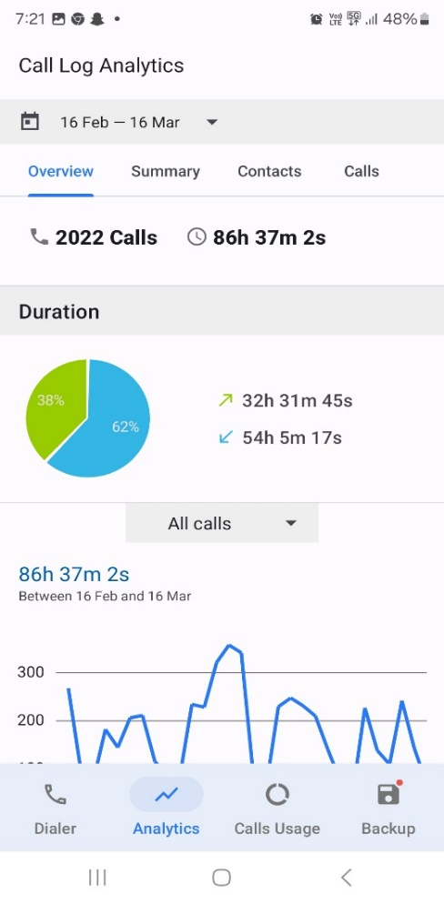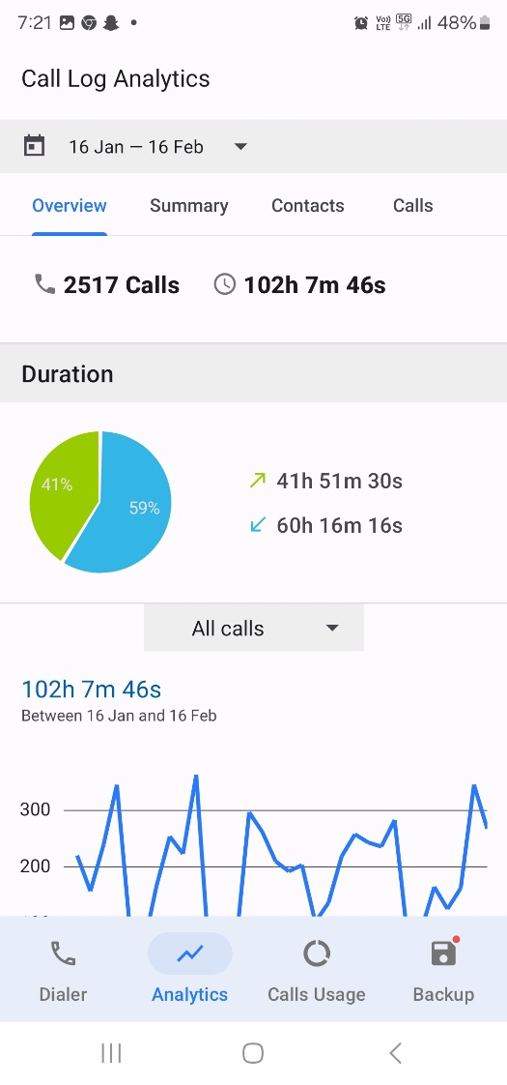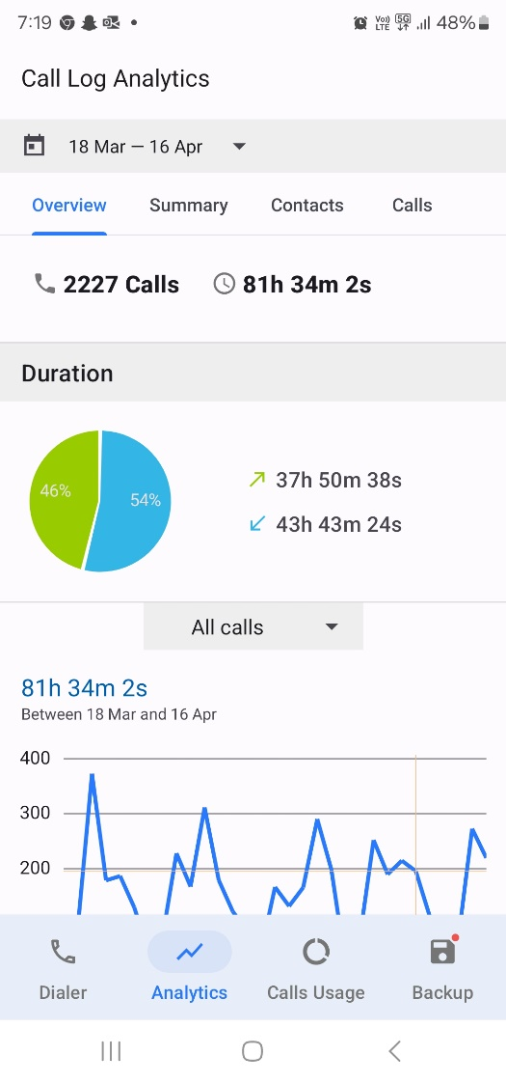

Clinton Cheney’s call logs

**Sandie Spencer, ambulance driver volunteer, and fire and rescue service volunteer**

*It would be very difficult for us to make an emergency phone call out at the farm, West Pingelly. The service has declined over the years to almost non existent.*

*I feel for the businesses in town... there's no way we could go to a cashless society, as you can't pay with a card some days.*

**Dusty Murray, regular visitor:**

*Matt and I noticed the decline in reception when we visited out there a few months ago. So many dead spots or very very weak reception.*

**Local nurse and town resident**

*Whenever I am on call for the Health Centre at night, I find it very difficult to get any sleep as I am constantly worried about missing phone calls to do a patient transfer due to the terrible phone reception.*

*It is impossible to make or receive phone calls inside the house and so very difficult to keep in touch with friends and family.*

**Tricia James, town resident::**

*Our phones are constantly dropping out.*

**Murray Dennerley, town resident:**

*Sometimes I have to walk outside to get service and make a call and I live 900 metres from the Main Street.*

**Catherine Hughes,** **main street business owner:**

*It is hard running a business when the majority of people pay by card and they are forever trying to get "range" so they can log into their bank and so they can pay for their good purchased. If they cannot log in then they go home empty handed.. Essentials unable to be purchased from Medicines, Food locally even paying bills at the PO.*

*Phone line conversions constantly drop out and that's even before you try about five times just to connect. You have to restart your phone constantly.*

**Catherine Hughes, rural resident (near a telecommunications tower):**

*Living on a farm, Telstra actually refused to fix our landline as the cable was eroding due to being hung on fence lines and they couldn't fix the issue. So we reply solely on mobiles for all calls as the booster constantly drops out of range, receiving missed calls when the phone never rung and calls dropping out mid-sentence.*

*Note that Catherine Hughes provided two submissions, one based on her experience running a small business Pingelly’s main street, and a second based on her experience living near Pingelly.

**Jaime Cheney, Perth resident with family in Pingelly:**

*I can’t ring my boys. They live 2 hours away!*

**Kylie Boz, mobile business owner:**

*I had to call my mother in-law 9 time just to have a conversation it kept disconnecting. And the tv doesn’t work hardly ether poor connection.*

**Peter Narducci, Captain volunteer fire and rescue service, town centre resident:**

*Our DFES Comm Ops Centre and BART Call Out system rely on good connectivity to be able to alert firefighters to attend an incident. Our current mobile network is far from reliable and it is a concern that we could fail to turn out to an incident due to a poor telephone network. It is a big concern for all of us!*

**Kerry Smart, rural resident:**

*It's really bad in Popanyinning too getting worse not better!! Been here 10 years and managed but the last 6 months it's been terrible.*

**Michael Hughes, mobile mechanic:**

*I have both Telstra and OPTUS sim cards in my truck for internet access, also use for Wi-Fi calling as the Telstra network is getting worse by the day...not looking forward to the 3G network closing as 4G and 5G haven't come close to the coverage 3G used to provide.*

**Cheryl Warner, town resident::**

*The service in Pingelly is not good!*

**Malcolm Jetta, town resident, Aboriginal representative, and CEO of a not-for-profit business:**

*It is very embarrassing dropping in and out of online Teams Meetings with colleagues. Plus not being able to pay for things without waving your phone around like it's a magic wand. I'm just about over it. Oh, and don't even get me started on the missed calls that come through without the phone even ringing.*

**Leonnie Messenger, main street business owner:**

*It is really bad when in the Main Street of town and you have to connect to your Wi-Fi (if working) to make a phone call or e-banking very frustrating not only for our business but personal as well…it is not only in the main street it’s all over town & been a loyal for a very long time and sometimes with the service we get you begin to think twice.*

**Storm Nyssen, internet business owner and town resident:**

*There is minimum reception which makes it very difficult and frustrating to run an online business.*

**Part 2 – Mobile Coverage – Survey**

The Shire of Pingelly also has completed a survey of the Pingelly townsite to measure mobile phone coverage (dBm). This survey was completed on 16/04/2024. A previous survey was completed 09/09/2022. Comparing the results of these surveys, mobile coverage has worsened from an average of -108.9dBm in 2022 to an average of -116.6dBm in 2024. Note that the higher average (recorded in 2022) denotes better mobile coverage. Note also that both averages have been taken excluding the data from map locations # 5, 32 and 33 as no data was recorded for these location in 2022. It is acknowledged that mobile coverage can vary with a number of conditions such as weather, however there are no apparent causes for any variation between the dates.

The below is a map of the results of this survey. Please note that the survey was done outside and that coverage reduces when inside a building. This means in areas that are red/orange, it is likely that there will be no mobile coverage inside the houses or businesses.

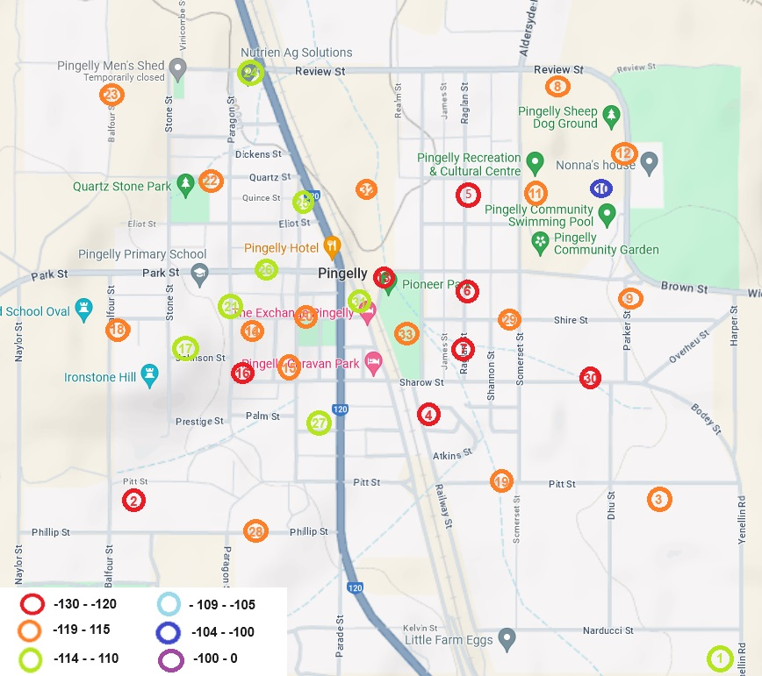

**Mobile Coverage - RSRP (dBm)**

|  |  |  |  |
| --- | --- | --- | --- |
| Map # | Location | 2022 dBm | 2024 dBm |
| 1 | Yenelling Road | -113 | -110 |
| 2 | Pitt Street | -111 | -129 |
| 3 | Pitt Street | -122 | -117 |
| 4 | Railway Street | -119 | -125 |
| 5 | Raglan Street |  | -125 |
| 6 | Raglan Street | -123 | -124 |
| 7 | Raglan Street | -114 | -128 |
| 8 | Review Street | -107 | -118 |
| 9 | Parker Street | -116 | -116 |
| 10 | PRACC Behind Oval | -94 | -102 |
| 11 | PRACC Car Park | -114 | -115 |
| 12 | Parker Street | -116 | -115 |
| 13 | Brown Street | -117 | -120 |
| 14 | Pasture Street | -117 | -115 |
| 15 | Webb Street | -103 | -115 |
| 16 | Paragon Street | -108 | -122 |
| 17 | Johnson Street | -106 | -110 |
| 18 | Pasture Street | -116 | -119 |
| 19 | Pitt Street | -122 | -116 |
| 20 | Pasture Street | -114 | -118 |
| 21 | Paragon Street | -103 | -111 |
| 22 | Quartz Street | -115 | -117 |
| 23 | Stone Street | -114 | -115 |
| 24 | Review Street | -98 | -108 |
| 25 | Queen Street | -109 | -109 |
| 26 | Park Street | -107 | -113 |
| 27 | Taylor Street | -110 | -113 |
| 28 | Phillip Street | -114 | -116 |
| 29 | Shire Street | -128 | -118 |
| 30 | Sharrow Street | -120 | -128 |
| 31 | Quadrant Street | -106 | -110 |
| 32 | Snake Gully |  | -125 |
| 33 | 72Hr Parking |  | -115 |
| Average (not inc. map# 5, 32 and 33) | | -112.5 | -116.3 |

Teltonika provides the following guidance to understand signal strength:

|  |  |  |
| --- | --- | --- |
| RSRP | Signal strength | Description |
| >= -80 dBm | Excellent | Strong signal with maximum data speeds |
| -80 dBm to -90 dBm | Good | Strong signal with good data speeds |
| -90 dBm to -100 dBm | Fair to poor | Reliable data speeds may be attained, but marginal data with drop-outs is possible. When this value gets close to -100, performance will drop drastically |
| <= -100 dBm | No signal | Disconnection |

<https://wiki.teltonika-networks.com/view/RSRP_and_RSRQ>

No locations in 2024 even rated a ‘poor’ signal strength. All locations were classified as ‘no signal’, with frequent disconnections experienced.

**Mobile Download Speed**

|  |  |  |  |
| --- | --- | --- | --- |
| Map # | Location | 2022 Mbps | 2024 Mbps |
| 1 | Yenelling Road | 25.7 | 12.1 |
| 2 | Pitt Street | 22.1 | 3.18 |
| 3 | Pitt Street | 6.5 | 13.5 |
| 4 | Railway Street | 10.1 | 13.2 |
| 5 | Raglan Street | 13.4 | 15.4 |
| 6 | Raglan Street | 5.7 | 7.67 |
| 7 | Raglan Street | 53.9 | 7.26 |
| 8 | Review Street | 53.9 | 67.1 |
| 9 | Parker Street | 51.6 | 42.1 |
| 10 | PRACC Behind Oval | 55.1 | 75.7 |
| 11 | PRACC Car Park | 53.6 | 57.1 |
| 12 | Parker Street | 52.2 | 55.1 |
| 13 | Brown Street | 54 | 16.6 |
| 14 | Pasture Street | 52.8 | 15.2 |
| 15 | Webb Street | 54.1 | 18.4 |
| 16 | Paragon Street | 53.1 | 22.6 |
| 17 | Johnson Street | 52.9 | 38.5 |
| 18 | Pasture Street | 43.1 | 20.3 |
| 19 | Pitt Street | 15.5 | 13.9 |
| 20 | Pasture Street | 21.9 | 17.2 |
| 21 | Paragon Street | 55.5 | 46.9 |
| 22 | Quartz Street | 48.2 | 25.9 |
| 23 | Stone Street | 45.4 | 22.3 |
| 24 | Review Street | 53.6 | 27.3 |
| 25 | Queen Street | 36.7 | 28.2 |
| 26 | Park Street | 47.8 | 29.4 |
| 27 | Taylor Street | 43.1 | 32.6 |
| 28 | Phillip Street | 41.7 | 23.7 |
| 29 | Shire Street | 6.4 | 1.94 |
| 30 | Sharrow Street | 9.6 | 10.2 |
| 31 | Quadrant Street | 45.5 | 20.9 |
| 32 | Snake Gully |  | 4.59 |
| 33 | 72Hr Parking |  | 5.45 |
| Average (not inc. map# 32 and 33) | | 38.2 | 25.8 |

The average mobile download speed in Australia is 86.43 Mbps. Telstra 5G has a median download speed of 215 Mbps. (<https://www.redsearch.com.au/resources/mobile-data-statistics-australia/>, *Australian Mobile Data Usage Statistics 2023*, 6 July 2023)

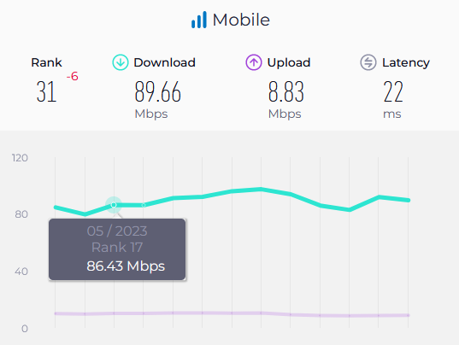These figures are borne out by Speedtest Golobal Index (<https://www.speedtest.net/global-index/australia>, March 2024)

The recorded download speed in Pingelly is less then 30% of the median speed and 12% of the Telstra 5G median speed. This is despite the recent upgrades to Telstra’s infrastructure in Pineglly to provide 5G services. These upgrades (or other factors) seem to have had a negative impact as Pingelly’s download speeds have decreased by 67.5% between 2022 and 2024.

**Mobile Upload Speed**

|  |  |  |  |
| --- | --- | --- | --- |
| Map # | Location | 2022 Mbps | 2024 Mbps |
| 1 | Yenelling Road | 2.7 | 1.1 |
| 2 | Pitt Street | 0.8 | 0 |
| 3 | Pitt Street | 0.8 | 1.95 |
| 4 | Railway Street | 0.3 | 0.72 |
| 5 | Raglan Street | 2.2 | 1.64 |
| 6 | Raglan Street | 0.5 | 0.54 |
| 7 | Raglan Street | 2.1 | 0.18 |
| 8 | Review Street | 5.1 | 13.5 |
| 9 | Parker Street | 3.1 | 8.3 |
| 10 | PRACC Behind Oval | 26.9 | 14.3 |
| 11 | PRACC Car Park | 7 | 6.4 |
| 12 | Parker Street | 0.8 | 7.71 |
| 13 | Brown Street | 2 | 0.95 |
| 14 | Pasture Street | 0.6 | 0.6 |
| 15 | Webb Street | 5.7 | 2.33 |
| 16 | Paragon Street | 7.4 | 1.46 |
| 17 | Johnson Street | 5.3 | 16 |
| 18 | Pasture Street | 1.4 | 7.46 |
| 19 | Pitt Street | 0.2 | 0.69 |
| 20 | Pasture Street | 1.1 | 1.33 |
| 21 | Paragon Street | 10.5 | 3.28 |
| 22 | Quartz Street | 1.6 | 3.63 |
| 23 | Stone Street | 5.5 | 2.31 |
| 24 | Review Street | 12.6 | 19.5 |
| 25 | Queen Street | 2 | 3.86 |
| 26 | Park Street | 2.9 | 4.06 |
| 27 | Taylor Street | 2.8 | 10.4 |
| 28 | Phillip Street | 2.1 | 9.07 |
| 29 | Shire Street | 0.1 | 0.29 |
| 30 | Sharrow Street | 0.1 | 0.59 |
| 31 | Quadrant Street | 2.7 | 2.38 |
| 32 | Snake Gully |  | 0.43 |
| 33 | 72Hr Parking |  | 1.17 |
| Average (not inc. map# 32 and 33) | | 3.8 | 4.7 |

The average upload speed in Australia is 8.83Mbps as recorded by Speedtest Golobal Index (<https://www.speedtest.net/global-index/australia>, March 2024). The average upload speed in Pingelly is approximately half of this figure, but varies widely.

**Part 3 – Internet Connection**

The Shire of Pingelly is extremely concerned about the lack of high speed wired internet services within Pingelly. The fixed wireless and satellite internet services appear to be comparable with other regional locations.

There is only one NBN node to service the while town which leads to significant lag, particularly at further away from the node. In addition, the copper wire is in a degraded state, no longer able to provide a reliable service.

For example, at one of the Shire’s houses, internet services was not available due to the degraded copper wire for the following periods:

24 October 2022 – 22 November 2022

20 December 2023 – 30 January 2024

05 March 2024 – 08 March 2024

22 March 2024 – 03 April 2024

This equates to outages approximately 10% of the last 2 years. This impacts the quality of life for many people, with many more devices now connecting to the internet. This includes smart TVs, Thermomix Food Processers, doorbells, home security systems etc. None of this equipment works without WI-FI. It has become indispensable. Many of the town’s residents and businesses (including the Shire of Pingelly) have now turned to starlink – despite the theoretical availability of internet through the copper wire network.

The establishment and growth of businesses are restricted by a lack of internet services. Access to reliable and high-speed telecommunications infrastructure is fundamental for regional development and innovation. High speed broadband internet and suitable mobile phone service is essential for all businesses for their establishment, operations, training and communications. Even traditional businesses rely on internet services for research, advertising, payment and financial control systems, including emailing quotes/invoices, stock ordering etc. The Optus outage (8 November 2023) demonstrated just how reliant businesses are on strong internet coverage. This outage halted trading at a wide range of businesses, from hairdressers through to banking services and online businesses, causing widespread outrage at the lack of what has now become an essential service. This is the daily experience of many businesses in Pingelly.

A report by Ernst & Young for the UK House of Lords in 2023 states: *'Unequal access to digital technologies is an issue where citizens in rural and deprived regions of the UK do not have access to the same quality of services to those living in more affluent towns and cities. This disparity undermines the opportunity to rebalance and grow the UK economy in years to come. Without equal opportunities to access digital technology, innovation, and social cohesion, the UK will struggle to maintain competitiveness in the long term.'* (<https://committees.parliament.uk/writtenevidence/119077/html/>) It is noted that similar circumstances apply to Western Australia and that a similar warning is relevant (despite the current strength of the mining industry) - that without equal opportunities to access digital technology, innovation, and social cohesion, WA may struggle to maintain competitiveness in the long term. It is imperative to ensure that all communities, regardless of their geographic location, have access to modern and efficient telecommunication services. The state government must ensure that equitable telecommunications services are provided in regional areas to bridge the digital divide and facilitate innovation across the state.

It is demonstrated that a faster internet connection makes for rural and regional towns to be [healthier and happier](https://www.nbnco.com.au/corporate-information/media-centre/media-statements/the-social-network-nbn-customers-reflect-on-healthier-happier-more-enriching-quality-of-life) as well more [prosperous](https://www.nbnco.com.au/corporate-information/media-centre/media-statements/boom-town-accenture-research-correlates-faster-stronger-nbn-with-greater-regional-workforce-participation).  These impacts are more pronounced in lower socio-economic areas. The town of Pingelly is in the 7% most economically disadvantaged places in Australia (Socio-Economic Indexes for Areas rankings). It is decisions like this that ensure that towns like Pingelly retain this unwelcome distinction. Despite this, and the degraded copper wire network, Pingelly and towns like it are listed as locations which will be upgraded to a fibre to the premise. The towns announced by NBN Co in [2022](https://www.nbnco.com.au/corporate-information/media-centre/media-statements/nbnco-announces-suburbs-and-towns-where-an-additional-ninty-thousand-homes-and-businesses-will-become-eligible-for-fibre-upgrades) and [2023](https://www.nbnco.com.au/corporate-information/media-centre/media-statements/millions-more-aussies-ready-for-18x-faster-nbn) are in the Perth/Peel and the regional centres (Port Headland, Albany, Kalgoorlie-Boulder, Broome, Busselton, Bunbury, Margaret River, Northam, Narrogin, Harvey and Donnybrook). These are places that are already well serviced e.g. have a Services Australia branch, a hospital, a bank, a secondary school, etc. These places also have a reliable mobile network. It would make sense to prioritise locations without these services to at least provide reliable online services.

**Part 4 – Conclusion**

The combination of the lack of reliable mobile coverage and the poor state of the copper wire network makes the people and businesses Pingelly disconnected, vulnerable, frustrated, and angry. In towns such as Pingelly, there is a greater need for connection across distances than in metropolitan areas. However, the reverse of this is provided!

Whilst such abysmal telecommunication and other services are provided, regional towns including Pingelly will continue to struggle to attract residents, causing congestion in the cities. Remote workers and businesses will continue to have difficulty operating, leading to losses of productivity. Emergency Services will not be able to receive or respond to calls, with potentially fatal consequences.

The solutions are obvious – a new mobile phone tower for Pingelly and replacement of the copper wire network with fiber to the premise. This network is due for replacement in any case. These solutions are not radical, but equitable and should be implemented as soon as possible.