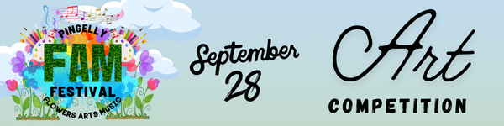

**Category – Adult**

**Class 1.** Painting - Acrylic or Oil

**Class 2.** Painting – Watercolour

**Class 3**. Dry Media - Charcoal, Pastel, Pencil, or other drawing medium

**Class 4.** Open - any other medium not listed above, including Mixed Media

**Class 5.** Photography

**Category - Youth**

**Class 6.** 13-18 years - Art (any traditional or digital medium)

**Class 7.** 13-18 years – Photography

**Class 8.** 12 years & under - Art (any traditional or digital medium)

**Class 9**. 12 years & under – Photography

**People’s Choice Award: $200**

All entries will be eligible for a people’s choice award and entered automatically. Votes for People's Choice will be collected throughout the exhibition day, and winners will be announced on social media after the conclusion of the FAM Festival.

**PRIZES**

**Adults**

**Class 1-5:** 1st $100 2nd $50

**Overall Winner of Categories 1-5: $500**

**Youth**

**Class 6-9:** 1st $50 2nd $25

**Overall Winner of Categories 6-9: $200**