LICENCE AGREEMENT FOR THE SHIRE OF PINGELLY AND PINGELLY RECREATION & CULTURAL CENTRE

The Shire of Pingelly provides public notice that it proposes to enter into a 10 year lease with a 6 year extension option agreement with CRISP Wireless for the installation operation of antenna equipment.

The Shire invites submissions to be made prior to 4 July 2024 to Storm Nyssen, Governance and Executive Officer by email at storm.nyssen@pingelly.wa.gov.au or in writing by post or in person to the Shire’s Administration Office at 17 Queen Street, Pingelly.

For further information, please contact Mrs. Storm Nyssen, Governance and Executive Officer at the Shire of Pingelly on 08 9887 1066 or email storm.nyssen@pingelly.wa.gov.au

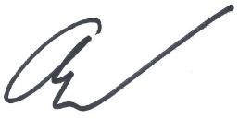

Andrew Dover
Chief Executive Officer Shire of Pingelly
17 Queen Street
Pingelly WA 6308

