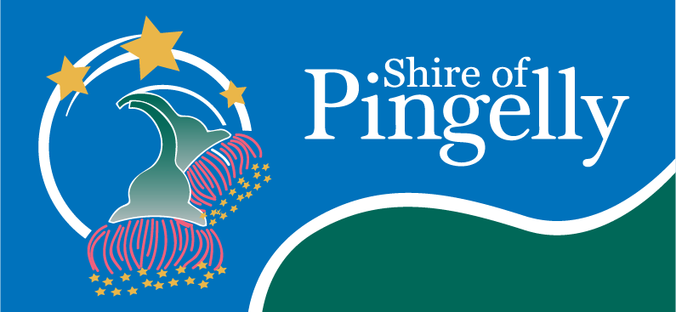**Overview**

The Shire of Pingelly has long been extremely concerned regarding the Department of Transport’s Student Transport Assistance Policy in relation to student transport as it has significant impacts for the Shire and residents in relation to student outcomes, equity and economic development. These impacts are articulated in the below sections.

**Background**

Following the closure of Pingelly Senior High School in 2005, high school students have been required to attend the Brookton District High School, Narrogin Senior High School or St Matthew’s Catholic School in Narrogin. The current Student Transport Assistance Policy only provides transport to the closest available school – which is Brookton District High School. Unfortunately, this school only provides a limited range of subjects in comparison to the schools in Narrogin. In addition, it only provides education up until Year 10 at which point the options are to leave school or to attend one of the schools in Narrogin. Under the current policy, transport is also provided for Year 11 and 12 students to attend Narrogin Senior High School.

**Student Outcomes**

It is very evident that the current Student Transport Assistance Policy has failed the people of Pingelly. The town of Pingelly has the following Highest Level of Educational Attainment in comparison to Western Australia and Australia:

|  |  |  |  |
| --- | --- | --- | --- |
| Highest Level of Education | Town of Pingelly | Western Australia | Australia |
| Degree Level and above | 3.9% | 20.5% | 22% |
| Year 12 | 9.8% | 16% | 15.7% |
| Year 10 | 21.7% | 11.8% | 10.8% |
| Year 9 and below | 14.4% | 5.9% | 8% |

The above data (Census 2016) states that 36.1% of Pingelly people have a Year 10 education or below compared with 17.7 % and 18.8% for Western Australia and Australia respectively meaning that in Pingelly a student is twice as likely to leave school at the end of Year 10 or before compared to Western Australia or Australia. This demonstrates the impact of current government policy which requires students to choose between changing schools from Brookton (and Pingelly before 2005) to Narrogin and leaving school altogether at the end of Year 10. It should be no surprise that many students chose not to continue their education given the options provided to them.

The longstanding Student Transport Assistance Policy has contributed significantly to the above as it forces students to attend Brookton District High School rather than providing a choice for students to attend Narrogin Senior High School from the start of Year 7. If this choice to attend Narrogin Senior High School was provided to students, students would not have the daunting decision either to start a new school at Year 11 as the ‘new student’ or leave school and enter the workforce. The choice at Year 11 then would be starkly different – to continue school with their friends or enter the workforce at a time when none of their peers are making that decision.

It is clear that since 2005 in Pingelly, the Student Transport Assistance Policy has pushed students to leave school prematurely resulting in low levels of education compared with the state and country and as a direct consequence is in the lowest 4% most disadvantaged as described by the Index of Education and Occupation (IEO) score (Census 2016) in Australia.

**Inequity**

The current policy only provides an option for students to attend their nearest school. In regional areas such as Pingelly, this limits opportunity for students in comparison to their peers in the metropolitan region who have multiple transport options and therefore multiple choices of schools to attend. In this regard, providing only a single option when other options are feasible is an example of inequity and disadvantage that rural, regional and remote areas experience which have a direct impact and ongoing upon the lives of the people that live here. In the case of Pingelly, transport is only provided under this policy to Brookton District High School for Years 7-10 and Narrogin Senior High School for Years 11 and 12 which forces students to attend these schools. As Brookton District High School does not offer the range of subjects that other metropolitan and the Narrogin Senior High School provides, students do not currently have the option to study these subjects which restricts their career possibilities and potential and study those subjects that best fit their aptitudes. When students are study subjects which fit their aptitudes, they can grow in confidence and be tested on their abilities rather than their inabilities. This concept is overstated for impact with the following famous quote *“If you judge a fish by its ability to climb a tree, it will live its whole life believing that it is stupid”* Author Unknown.  This alone is enough cause to change the Student Transport Policy.

To overcome the above equity and student outcome issues, some Year 7-10 students attend Narrogin Senior High School with the idea that they will continue their education from Year 7 through to Year 12 at the same school and have access to a wider diversity of subjects which are the best fit for their aptitudes. However, these Year 7-10 students are not guaranteed seats on the bus that goes from Pingelly (and Brookton) to Narrogin Senior High School for the Year 11-12 students and for St Matthew’s Catholic School in Narrogin. As a result, if a Year 7-10 student is on the bus traveling to Narrogin Senior High School and if either a Year 11-12 or fee-paying student attending St Matthew’s Catholic School from any year cannot find a seat, the bus driver is obliged to as the Year 7-10 student to exit the bus and will leave the student at the side of the road – a potentially dangerous situation for the student. The student’s parent or guardian are then required to bring the student (a 200km round trip) to school. If the parent or guardian is unavailable for work, medical or other reasons and cannot arrange alternative transport, the student will not attend school that day. This then counts against their school records of attendance and leaves the student trying to catch up academically to their classmates. This is not hypothetical, it something that frequently happens to Pingelly students and is another example of injustice and inequity experienced by Pingelly and other rural, regional and remote students on a daily basis. The fact that the ‘older kids’ in Years 11 and 12 and the ‘rich kids’ attending the fee-paying school (primary and secondary) have priority over the students most in need of assistance is highly concerning and target those families least able to pay to attend the fee-paying school.

**Economic Development**

The above student outcomes and most particularly the inequity of the current Student Transport Assistance Policy has a significant impact upon the Shire of Pingelly’s economic growth and development. This policy encourages families to leave from Pingelly before their children enter High School as shown on the below graph.

Tertiary Students

Primary School Students

Pingelly has similar percentages of primary school age children when compared to Western Australia and Australia, however this dips dramatically at high school age, including the parents of those students at the 30-44 age range and does not recover until the 50-54 age bracket at which stage the percentage of population these in older categories is driven upwards as the percentage population in the younger categories are driven downwards. In contract, the nearby town of Narrogin (which has suitable access to secondary schools) retains its population during high school age and experiences a small dip as the population enters the Tertiary Education age. Overall, Narrogin’s population decreases less then Pingelly’s population. This demonstrates that the lack of suitable access to high school education is a major contributing factor in families leaving Pingelly.

This analysis is reinforced by the consultation with young people in the Pingelly Community carried out as part of the Shire of Pingelly Youth Strategy 2021-2025. Young people articulated the below key concerns about their future.

***Pingelly Youth Consultation***

*Many young people are not able to access education… opportunities close to home and need to leave the region to pursue them. There is a notable decrease in young people’s confidence when comparing their desire to remain in Pingelly and the practicality of doing so.*

*A key concern for young people is remaining connected to Pingelly and maintaining friendships while completing high school in neighbouring communities.*

(Shire of Pingelly Youth Strategy 2021-2025 – Future Aspirations, page 14)

The economic ramifications of this high school age flight of both students and their parents from Pingelly are glaring and significant, particularly as Pingelly is experiencing a shortage of workers.

In addition to the flight of existing residents, the current Student Transport Assistance Policy deters families from moving to Pingelly. One particular example is a recently appointed government official who preferred to commute to Pingelly from Perth rather than move their family to Pingelly because of the risk that their children would be left at the side of the road by the school bus. The Shire of Pingelly has noted several instances in which this policy has been directly responsible for families making the decision not to move to Pingelly. As the population of the Shire of Pingelly is 1,146 people (2016 Census), the impact of a number of family’s decisions not to move to Pingelly has an outsized impact. This is the difference between the current stagnating population (which was 1,168 people in 2006 – a difference of 22 people over 10 years to 2016) and a sustainably growing population of 1% or 2% per year.

A population growth of 1% year on year for Pingelly (approx. 200 additional people since 2006) would mean additional houses being built, stable house prices, a more sustainable local economy supported by the additional population and increases in the rates base partially negating the need for rate increases. This modest population growth is being prevented by the current Student Transport Assistance Policy which has deterred families from moving to Pingelly and encouraging families to move from Pingelly resulting in a weaker local and regional economy.

**Conclusion**

The current Student Transport Assistance Policy does not make logical sense when applied to Pingelly, considering that under this policy a bus service operates from Pingelly to both Brookton and Narrogin. Simply a larger bus to Narrogin on the existing service would provide a suitable option for all students to attend the school of their choice.

As a result of the student outcomes, current inequity and impact on economic development, there is a social, moral and financial imperative respectively for the current Student Transport Assistance Policy to be changed and an adequate bus service to be provided which guarantees a seat for all Pingelly students to travel to attend the Brookton District High School, Narrogin Senior High School or St Matthew’s Catholic School in Narrogin according to their choice.

Signed for the Shire of Pingelly and on behalf of the residents of Pingelly:

|  |  |
| --- | --- |
| Mr. Andrew Dover  **Chief Executive Officer**  20 October 2021 | Cr. William Mulroney  **Shire President**  20 October 2021 |